About DAIHEN Smart Solutions Europe
DAIHEN Smart Solutions Europe is the European competence network of listed Japanese DAIHEN Corporation. The brand serves as the umbrella under which six subsidiaries – OTC DAIHEN Europe, Lorch Schweißtechnik, DAIHEN Varstroj (Slovenia), Femitec, Rolan Robotics (The Netherlands), and LASOtech Systems – are bundling their expertise in welding technology and robotization. They pursue the objective of supporting industrial customers across Europe and beyond with integrated, turn-key automation solutions. The network represents quality, innovation power, and customer-specific solutions in the areas of industrial welding and cutting technology – for companies of all sizes.

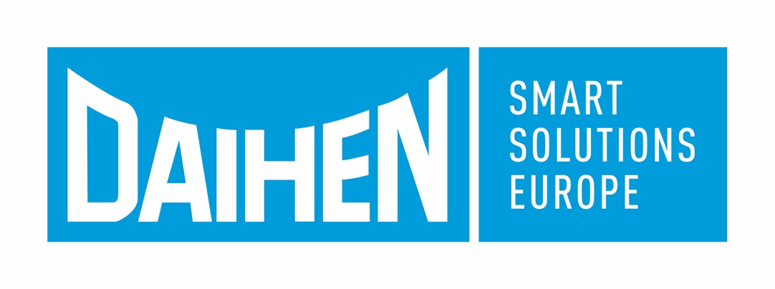
Figure 01: Six subsidiaries of DAIHEN group are going to offer turn-key automation solutions in a competence network under the DAIHEN Smart Solutions Europe brand in future.

Press contact:
DAIHEN Smart Solutions Europe
c/o Lisa Michler
info@daihen-smartsolutions.com

Print free of charge.
Voucher copy requested.

